**Roll No:** 20481A0515

**Name:** AYINAMPUDI VENKATESH



**Roll No:** 20481A0527

**Name:** CHALAMALASETTI DINESH



**Roll No:** 21481A05L3

**Name:** SUDABATHULA SRI HARSHITHA

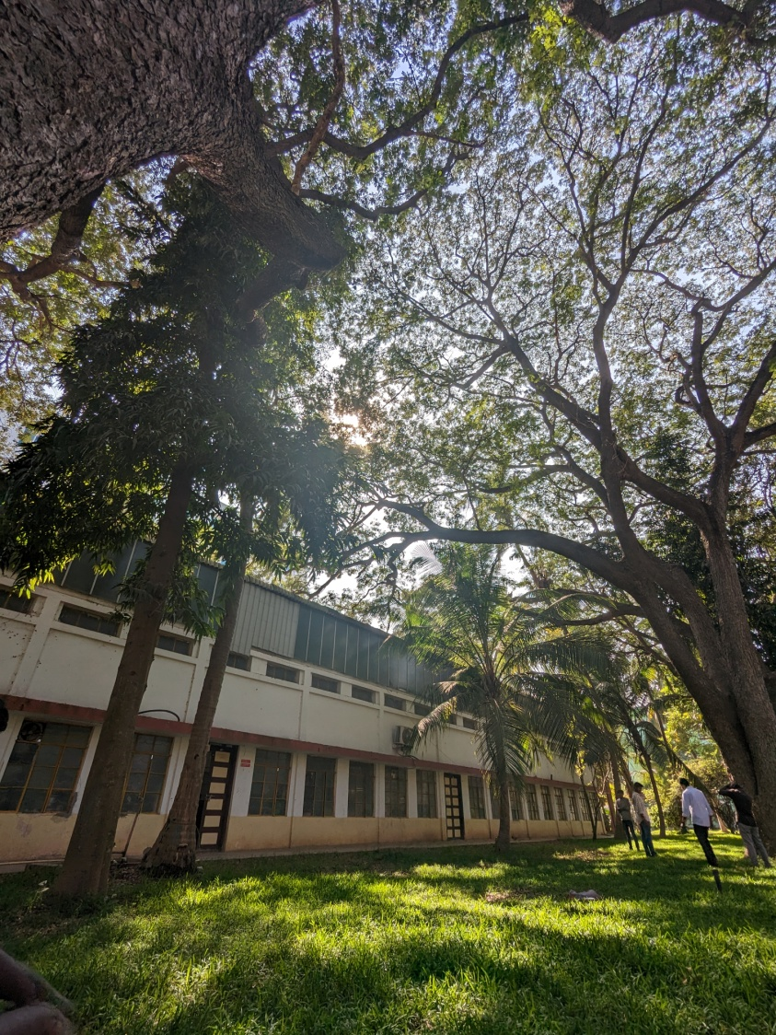

**Dr. T. Srinivasa Rao Dr. M. Babu Rao**

**(COMITY Advisor) (HoD, CSE)**